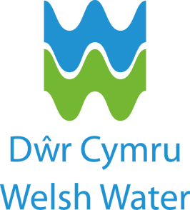

Dŵr Cymru Welsh Water - Graduate Programme

Welsh Water is the sixth largest of the ten regulated water and sewerage companies in England and Wales. Responsible for providing over three million people with a continuous, high quality supply of drinking water and for taking away, treating and properly disposing of the wastewater that is produced, we are fully committed to delivering best quality service at least possible cost.

The Programme
Our fast paced programme will ensure that no two days are the same and will provide a safe yet challenging learning environment to develop your knowledge, skills and experience. Honing and developing your natural management and leadership ability.

We want to change our part of the world for the better. So, we like to go above and beyond to give our customers memorable experiences. We do this by implementing LEAN working practices that help streamline the way we work, and put our customers first through our Customer Led Success approach, we test everything we do through the eyes of the customers.

This year’s programme offers opportunities in our Water, Wastewater and Retail Services, Capital Delivery Alliance and Data Science teams.

For more information and to apply please visit our website
http://www.dwrcymru.com/en/Talent-Search.aspx

We're looking for business minded, innovative, driven and above all talented individuals who aspire to be our people managers of the future. Join us for the opportunity to lead our business in providing an essential service to over three million people.

