Computer Science, Industrial Year Placement at RHE

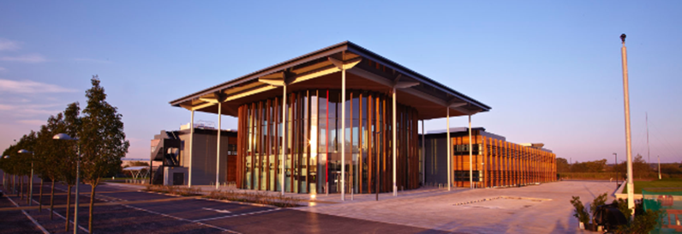

An exciting opportunity has arisen to add a Junior Developer to our Bristol based software team. Join us and work with the latest web technologies to develop intelligent cloud applications which save lives.

Location: Bristol

Salary: £16,000 p.a

Contract: Temporary 12 to 14 months

Hours: 35 hours/week

We are a small company making a big impact. Our company RHE is the market leader in supplying specialist software to government, with 80% market share in the UK and Australia. We are soon expanding into Asia and North America. Our products have a sound ethical profile, our Noise App has been credited with saving lives on more than one occasion.

We develop innovative cloud software solutions for government, business and professionals. We lead the market with self reporting apps for citizen engagement and knowledge management for the regulatory and compliance industry.

We are currently beta testing a new case management system for use across government and business.

Our current products include:

● The Noise App (a noise nuisance reporting app for iOS and Android built alongside a web application allowing reports to be reviewed)
● RIAMS (knowledge management web application for government services)
● Whitedocs (innovative AI-driven case management tool)

To help expand our exciting portfolio of software and services, we are looking for an ambitious web developer with a keen interest in front-end technologies, artificial intelligence, and creating outstanding user interfaces for the tens of thousands of users that our products serve daily.

We are open minded about technologies and are always looking to use the best tools possible to take our products forward. Your technical role will be pivotal in helping RHE on its trajectory to global success in both the government and regulatory industry, and beyond into new markets by cooperating with the sales and management teams.

RHE maintain three modern offices located in Bristol, Aberystwyth and Carmarthenshire. We work in an agile environment with a very positive workplace ethic. You will be given well structured opportunities to lead on sprints as well as supporting the Senior Developers in more complex technical work. The role will be well supported and offers a very positive development step for a junior developer.

To apply, please send a covering letter and CV to jobs@rhenvironmental.co.uk. If you would like to speak to one of the development team about this exciting opportunity, please call us on 0117 403 3584.

Closing Date: 28/10/2016 - Aber

