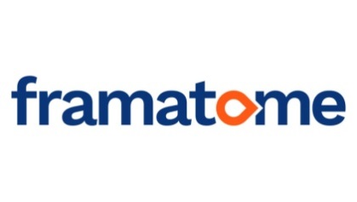
Framatome GmbH
Paul-Gossen-Straße 100
91052 Erlangen
http://www.framatome.com/EN/home-57/index.html
Deutschland
Tel.: +49 9131 900 91293

Computer Science Student Placement for summer 2020 - summer 2021 in areas:

Instrumentation and Control - C++ Tool Development (1 position available)
Instrumentation and Control - Web Application Design (1 position available)
Installed Base – Big Data Analytics using Python and Dashboard Development (2 positions available)

Job offer
Framatome GmbH, Germany, is offering a one year work placement/internship to Computer Science Students (or related computing courses e.g. Information Technology) for the year 2020-21. The starting date during summer of 2020 is to be discussed during a telephone interview.
Requirements:
1. Studying a Computer Science course (other related computing courses will be considered e.g. Information Technology).
2. Knowledge of Version Control software (e.g. GIT) and software methodologies such as Scrum.
3. Good written and spoken English
Job Specific Requirements:
C++ Tool Development
- Good knowledge of C/C++ and optionally the Qt framework.
- Knowledge of scripting languages (BASH, Python, etc.) an advantage.
- Knowledge of Linux an advantage.
Web Application Design
- Good knowledge of web-based technologies (scripting, mark-up languages, PHP, HTML5)
- Knowledge of database systems (SQL, Oracle, MySQL, etc.).
Big Data Analytics using Python and Dashboard Development:
- Good knowledge of web-based technologies (scripting, mark-up languages, HTML5)
- Knowledge of at least one high-level programming language (C/C++, C#, Java, Python, etc.).
- Knowledge of database systems (SQL, NoSQL)
- Knowledge of Big Data Systems an advantage (Hadoop, Teradata, MapR, Cloudera)
The successful applicant will work closely with one of our project managers, aiding in current projects. The working language is English, but it is expected that the students will engage in learning German during their Internship.
This is a paid internship (approx. €1100 p/month)

Please email your CV (English or German) and a cover letter by 31st Jan 2020 at the latest to David Newham at:

david.newham@framatome.com

For any related queries please also contact David Newham at the above email address.

In your cover letter, please clearly state which role you are primarily applying to. If this role has been filled, you will still be considered for the other positions, as opportunities to develop your own personal strengths/weaknesses and interests are available in all roles.

NB: Candidates will be considered upon receipt of application, so early application is advised.

NB: Conclusion of an employment contract and/or employment conditions will be subject to the result of Brexit negotiations and at this time we cannot provide any guarantees in this respect.

